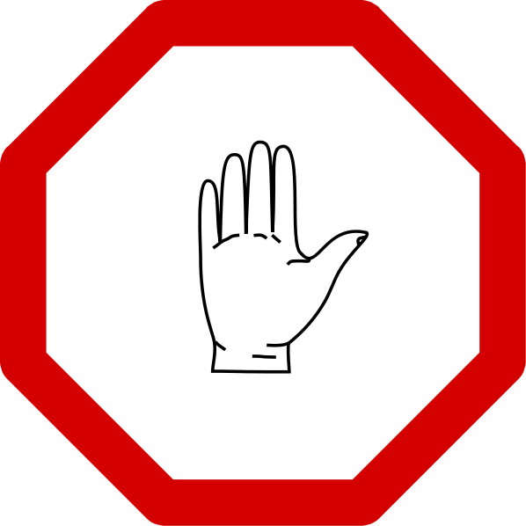

Please do not enter the practice unless you have completed our screening process and have an appointment.

If there is already a person waiting in Reception please wait outside until we collect you.

To make an appointment please call (insert number)
or send an email to (insert email)

Thank you for your understanding.

